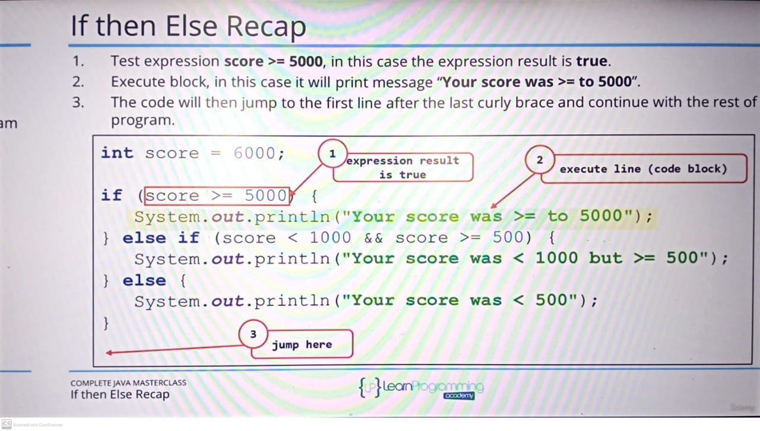

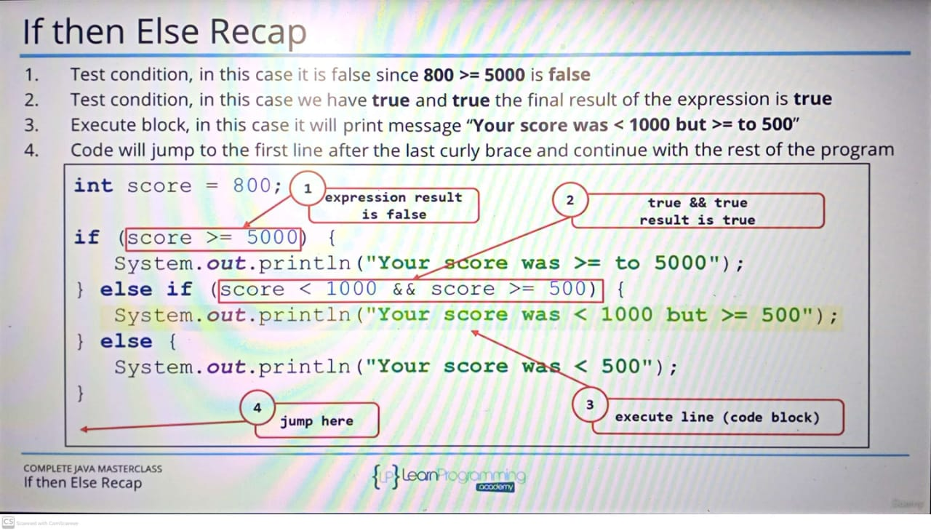

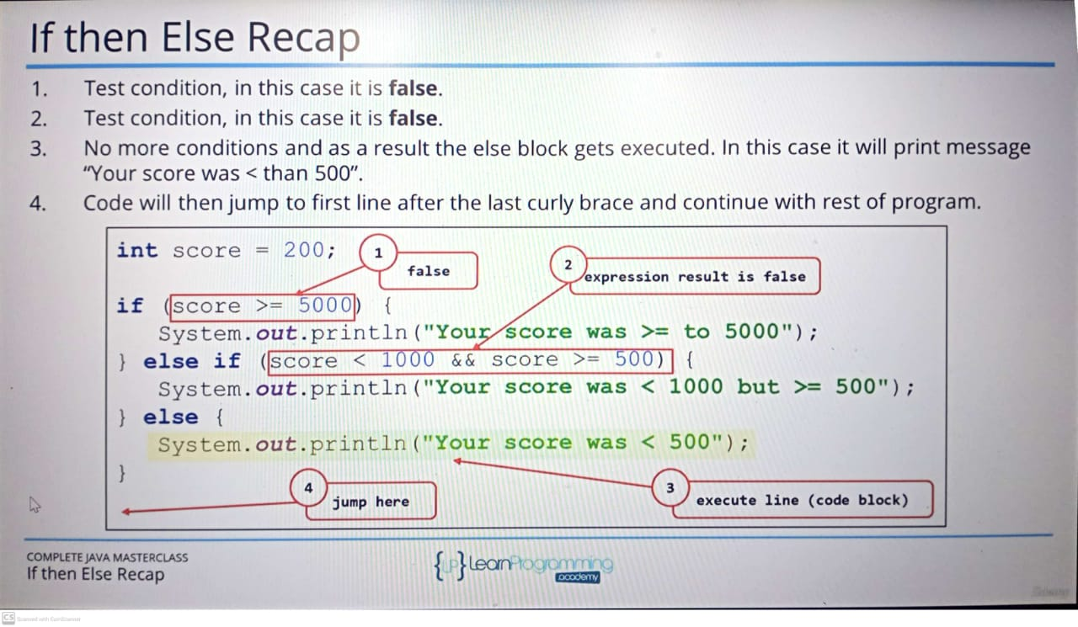

* <https://www.w3schools.com/java/java_conditions.asp>

- read only if, else and else if concepts [**REMEMBER {},CURLY BRACES OF IF, ELSE , AND ELSE IF I.E WHERE TO USE IT and also rem (), here we put condition and also rem () > {} ]**